Table of Contents
Table of Contents 1
OSPF 2
Lab 017 Graceful Restart 2

OSPF

Lab 017 Graceful Restart
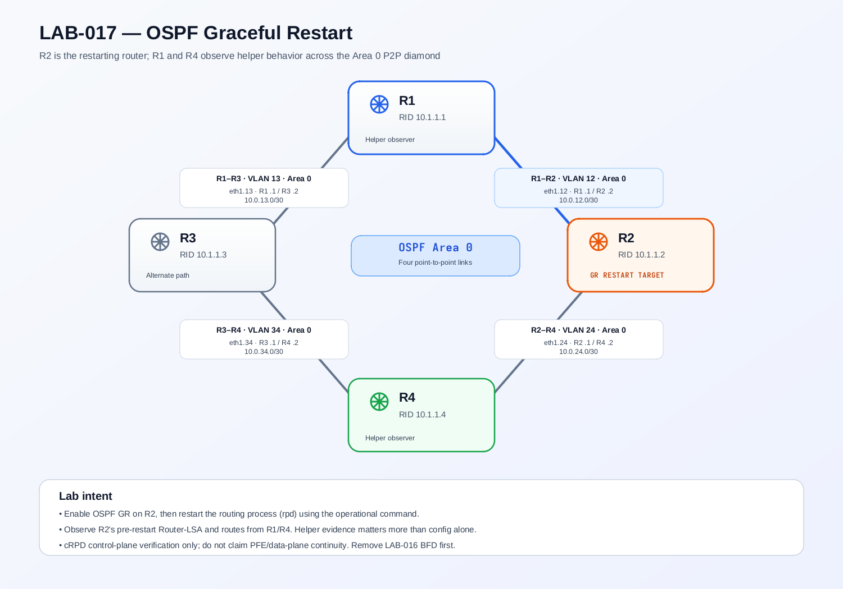

Load Config
NOTE: This lab use vjunos_router found on folder /jnciesp.
# r1,r2,r3,r4
conf
load override http://10.0.0.2:81/ospf.graceful.cfg routing-instance mgmt_junos
commit

TASK 1
Configure OSPF Graceful Restart for the R2 that will restart. Keep the other routers as helper candidates using their supported/default helper behavior. Do not disable strict LSA checking or disable helper capabilities for the core exercise.
- R2's OSPF overview indicates Graceful Restart is enabled.
- R1 and R4 report the appropriate OSPFv2 helper-mode capabilities enabled, or the exact deviation is documented.
- All four OSPF adjacencies remain Full before the restart.
- R1's ECMP route and LSDB baseline are recorded immediately before the restart.

TASK 2
Restart the routing protocol process on R2 only. Do not restart/stop the whole container, and do not flap links. Observe from R1 and R4 while R2's process is restarting, then inspect R2 after it returns.
Prove or disprove the following expected behavior with operational output/logs:
- R1 and R4 recognize/support R2's graceful restart and preserve their pre-restart view of R2 while the topology remains unchanged.
- R1 continues to show the route to 10.1.1.2/32 during the helper window when the implementation behaves as expected.
- R1's route to 10.1.1.4/32 retains both equal-cost paths via R2 and R3 during the GR window, if helper behavior on this image preserves that RIB state.
- R2's OSPF adjacencies return to Full and its routing/LSDB state resynchronizes after the process restart.
- The GR operation completes rather than remaining indefinitely pending or ending due to a topology/LSA change.

Lab 018 LFA Link Protection
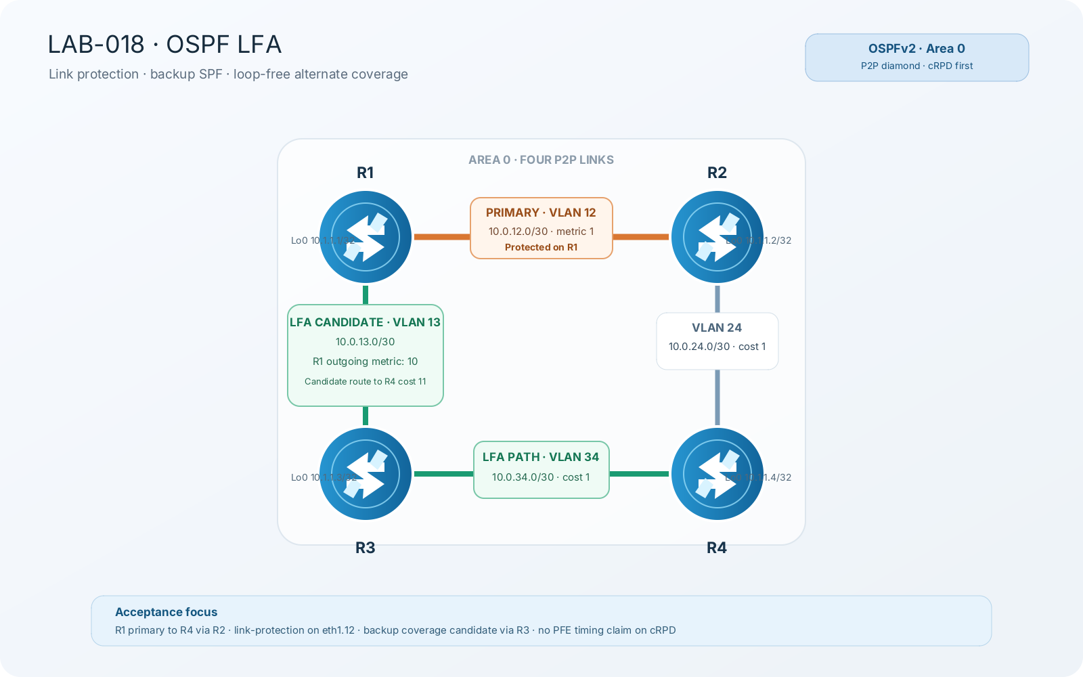

Load Config
NOTE: This lab use vjunos_router found on folder /vJunos-Router.
# r1,r2,r3,r4
conf
load override http://10.0.0.2:81/ospf.graceful.cfg routing-instance mgmt_junos
commit

TASK 1
Establish that all four expected P2P adjacencies are Full. Explain why R1's primary route to 10.1.1.4/32 is via R2, and show that the path through R3 is topologically loop-free for this destination.
- OSPF neighbor table for R1-R4.
- R1 route detail for 4.4.4.4/32 showing primary next hop via 10.0.12.2 / ge-0/0/0.12 and metric 2.
- Router-LSA / route evidence sufficient to explain the R1-R3-R4 alternate path.
- Effective metric on R1 eth1.13 and note that the interface cost is directional.
Note : The RFC-style loop-free condition for alternate neighbor N=R3, local repair point S=R1, destination D=R4 is D(N,D) < D(N,S) + D(S,D). Here D(R3,R4)=1, D(R3,R1)=1 (R3's outgoing metric toward R1), and D(R1,R4)=2, so 1 < 1 + 2. Therefore R3 is a valid loop-free alternate candidate for R4.

TASK 2
Provide link protection for the R1-R2 interface that carries the primary route to R4 loopback. Make the minimum change.
- Effective OSPF interface configuration for R1 ge-0/0/0.12.
- show ospf backup coverage.
- show ospf backup neighbor
- show ospf backup spf detail
admin@r1# run show ospf backup coverage
Topology default coverage:

Node Coverage:

Area Covered Total Percent
Nodes Nodes Covered
0.0.0.0 2 3 66.67%

Route Coverage:

Path Type Covered Total Percent
Routes Routes Covered
Intra 4 8 50.00%
Inter 0 0 100.00%
Ext1 0 0 100.00%
Ext2 0 0 100.00%
All 4 8 50.00%

admin@r1# run show ospf backup spf detail
Topology default results:

Area 0.0.0.0 results:

2.2.2.2
Self to Destination Metric: 1
Parent Node: 1.1.1.1
Primary next-hop: ge-0/0/0.12 via 10.0.12.2
Backup Neighbor: 2.2.2.2 via: Direct
Neighbor to Destination Metric: 0, Neighbor to Self Metric: 1
Self to Neighbor Metric: 1, Backup preference: 0x0
Not eligible, Reason: Primary next-hop link fate sharing
Backup Neighbor: 3.3.3.3 via: Direct
Neighbor to Destination Metric: 2, Neighbor to Self Metric: 1
Self to Neighbor Metric: 3, Backup preference: 0x0
Track Item: 1.1.1.1
Track Item: 2.2.2.2
Not eligible, Reason: Path loops

3.3.3.3
Self to Destination Metric: 3
Parent Node: 4.4.4.4
Primary next-hop: ge-0/0/0.12 via 10.0.12.2
Backup next-hop: ge-0/0/0.13 via 10.0.13.3
Backup Neighbor: 3.3.3.3 via: Direct
Neighbor to Destination Metric: 0, Neighbor to Self Metric: 1
Self to Neighbor Metric: 3, Backup preference: 0x0
Eligible, Reason: Contributes backup next-hop
Backup Neighbor: 2.2.2.2 via: Direct
Neighbor to Destination Metric: 2, Neighbor to Self Metric: 1
Self to Neighbor Metric: 1, Backup preference: 0x0
Track Item: 3.3.3.3
Not evaluated, Reason: Interface is already covered

4.4.4.4
Self to Destination Metric: 2
Parent Node: 2.2.2.2
Primary next-hop: ge-0/0/0.12 via 10.0.12.2
Backup next-hop: ge-0/0/0.13 via 10.0.13.3
Backup Neighbor: 2.2.2.2 via: Direct
Neighbor to Destination Metric: 1, Neighbor to Self Metric: 1
Self to Neighbor Metric: 1, Backup preference: 0x0
Not eligible, Reason: Primary next-hop link fate sharing
Backup Neighbor: 3.3.3.3 via: Direct
Neighbor to Destination Metric: 1, Neighbor to Self Metric: 1
Self to Neighbor Metric: 3, Backup preference: 0x0
Eligible, Reason: Contributes backup next-hop

TASK 3 — CONTROLLED LINK-FAILURE OBSERVATION
- Simulate failure of R1's logical R1-R2 interface only.
- Do not shut down the physical parent ge-0/0/0
- Confirm that R1-R2 adjacency drops, R1-R3 remains usable, and R1 can reach 4.4.4.4/32 through R3 after normal OSPF reconvergence. Record the measured interruption without asserting that it represents LFA/PFE switchover.

